**REPORT ON**



# PINAKA

# (MULTI-BARREL ROCKET LAUNCHER)

## Submitted by :

**PANKAJ BEHERA**

**BALASORE COLLEGE OF ENGINEERING AND TECHNOLOGY**

**COMPUTER SCIENCE**

**20_CSE_29**

**Undertaken at**

**PROOF & EXPERIMENTAL ESTABLISHMENT**

**DRDO**

**CHANDIPUR**

## IINTRODUCTION

**Pinaka is a multibarrel rocket launch (MBRL) system used by the Indian Army. Developed by the Defence Research and Development Organisation (DRDO), Pinaka integrates state-of-the-art technologies for delivering superior combat performance.**

Pinaka is a multibarrel rocket launch (MBRL) system used by the Indian Army. Developed by the Defence Research and Development Organisation (DRDO), Pinaka integrates state-of-the-art technologies for delivering superior combat performance.

Pinaka is produced at an average rate of 1,000 rockets a year at the Ordnance Factory in Chanda, Maharashtra. The Ministry of Defence increased the output of the rocket by commencing production at the Ordnance Factory in Badmal, Orissa.

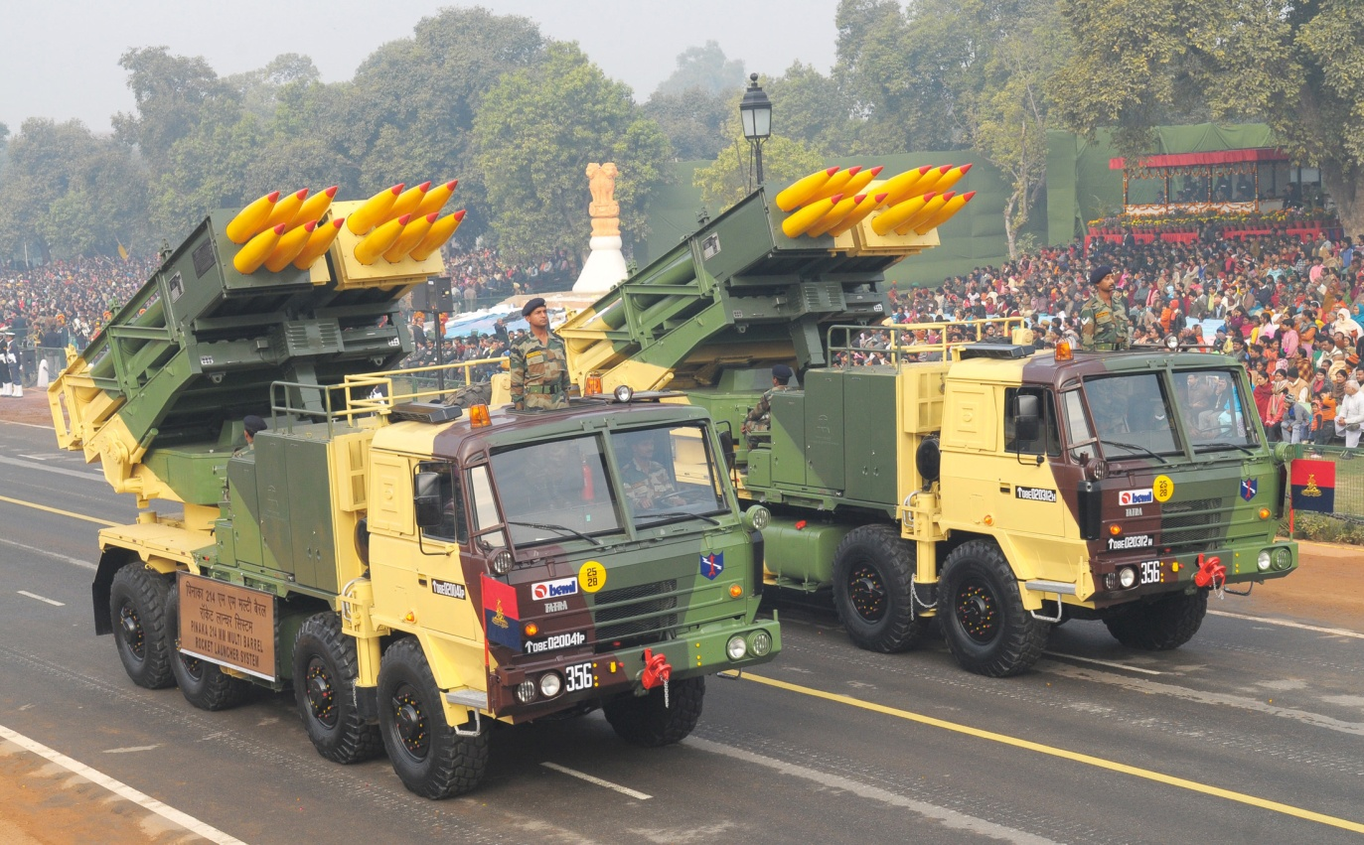

**DESIGN**

Pinaka was designed to replace the BM-21 Grad multiple rocket launcher systems of the Indian Army. It is a multifaceted system integrating high energy propulsion, sub-munition warheads, servo-controlled launcher configuration and fire control computer.

The Pinaka system is based on the 8×8 vehicle. Each battery is composed of six launcher vehicles, six loader-cum replenishment vehicles and two command post vehicles. Each launcher vehicle carries two pods, housing a total of 12 rockets.

Each Pinaka rocket can carry a 100kg payload for a range of 40km. A single Pinaka battery can neutralise a surface area of 700m x 500m. The system can engage targets with a circular error probability (CEP) of one to two percent of range.

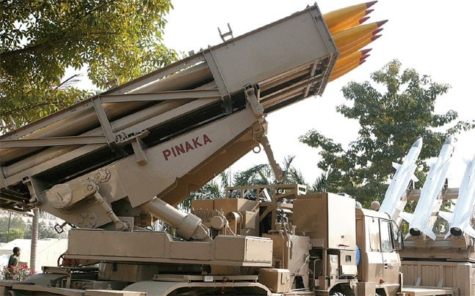

**SPECIFICATIONS**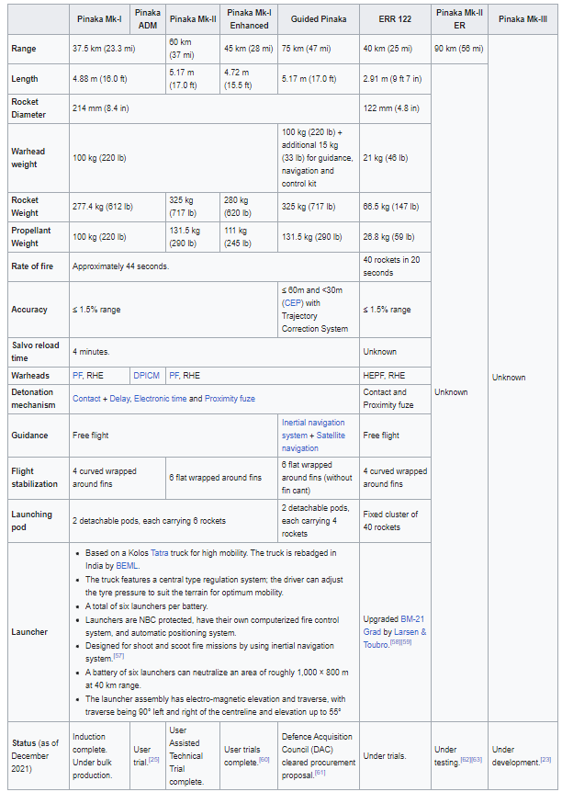

**DEVELOPMENT DETAILS**

Development of Pinaka commenced in 1986 at a Pune-based DRDO facility, known as Armament Research and Development Establishment (ARDE). DRDO was responsible for the overall design and development. The subsystems and components were developed by Tata Power SED, Larsen & Toubro and Ordnance Factories Board.

In March 2006, the Indian Army placed a $45m contract with Tata Power SED and Larsen & Toubro (L&T) to deliver 40 Pinaka MRBLs. The performance and firing capabilities of the launcher were presented in June 1996. Phase one user trials of Pinaka were carried out in June 1997. The phase two trials began in July 1998.

The combat capabilities of Pinaka MBRL were tested during the Kargil war in June 1999. The maiden Pinaka MBRL regiment was set up in February 2000. [Development trials](https://www.army-technology.com/news/newsindian-army-begins-pinaka-developmental-trails) of Pinaka were conducted at the Chandan firing range in Pokhran in September 2012.

The authority holding sealed particulars (AHSP) responsibility of Pinaka weapon system was transferred from DRDO to the Directorate General of Quality Assurance (DGQA) in September 2020. The transfer marks the successful establishment of production of Pinaka rockets, launchers, battery command posts, loader cum replenishment and replenishment vehicles as well as quality assurance processes.

In August 2020, the Indian government signed a Rs25.8bn ($353.5m) contract with Tata Power Company, L&T and Bharat Earth Movers for supplying six regiments of Pinaka Mk I MBRL systems to the Indian Army and are expected to be delivered by 2024.

In November 2020, DRDO successfully flight tested the enhanced Pinaka rocket from Integrated Test Range, Chandipur, off the Odisha coast. The enhanced version delivers long-range performance when compared to the earlier design with reduced length.

**DEPLOYMENT**

Each Pinaka regiment consists of three batteries of six Pinaka launchers; each of which is capable of launching 12 rockets with a range of 40 km in a space of 44 seconds. In addition to these, a regiment also has support vehicles, a radar and a command post.[[33]](https://en.wikipedia.org/wiki/Pinaka_multi-barrel_rocket_launcher#cite_note-ETDec2016-33)

The Pinaka will be operated in conjunction with the Indian Army's Firefinder radars and [Swathi Weapon Locating Radar](https://en.wikipedia.org/wiki/Swathi_Weapon_Locating_Radar) of which 28 are on order. The Indian Army is networking all its artillery units together with the DRDO's Artillery Command & Control System (ACCS), which acts as a force multiplier. The ACCS is now in series production. The Pinaka units will also be able to make use of the Indian Army's SATA (Surveillance & Target Acquisition) Units which have been improved substantially throughout the late 1990s, with the induction of the [Searcher-1](https://en.wikipedia.org/wiki/IAI_Searcher), [Searcher-2](https://en.wikipedia.org/wiki/IAI_Searcher) and [IAI Heron](https://en.wikipedia.org/wiki/IAI_Heron) UAVs into the Indian Army, as well as the purchase of a large number of both Israeli made and Indian made [Battle Field Surveillance radars](https://en.wikipedia.org/wiki/BFSR-SR).

These have also been coupled with purchases of the Israeli LORROS [Long-Range Reconnaissance and Observation System](https://en.wikipedia.org/wiki/Long-Range_Reconnaissance_and_Observation_System) which is a combination of [FLIR](https://en.wikipedia.org/wiki/FLIR)/[CCD](https://en.wikipedia.org/wiki/Charge-coupled_device) system for long range day/night surveillance.

### MODES OF OPERATION

The launcher can operate in the following modes:

**Autonomous mode.** The launcher is fully controlled by a fire control computer (FCC). The microprocessor on the launcher automatically executes the commands received from the FCC, giving the operator the status of the system on displays and indicators.

**Stand-alone mode:** In this mode, the launcher is not linked to the FCC operator, and the operator at the console enters all the commands for laying of the launcher system and selection of firing parameters.

**Remote mode:** In this mode, a remote control unit carried outside the cabin up to a distance of about 200 m can be used to control the launcher system, the launcher site and to unload the fired rocket pods from the launcher.

**Manual mode:** All launcher operations including laying of the system and firing are manually controlled. This mode is envisaged in the situations where the microprocessor fails or where there is no power to activate the microprocessor-based operator's console.

The Pinaka was tested in the Kargil conflict and proved its effectiveness. Since then it has been inducted into the Indian Army and series production has been ordered. The Pinaka MBRL is stated to be cheaper than other systems. It costs [₹](https://en.wikipedia.org/wiki/Indian_rupee)2.3 [crore](https://en.wikipedia.org/wiki/Crore) (US$290,000) per system compared to the M270 which costs ₹19.5 crore (US$2.4 million).

**NAVIGATION AND PROPULSION**

DRDO placed an order with Sagem for Sigma 30 artillery navigation and pointing systems to equip first two regiments of Pinaka in 2008.

The deliveries of Sigma 30 systems were concluded in June 2010. The systems were integrated into Pinaka by Tata Power SED and Larsen & Toubro.

The Sigma 30 is based on the laser gyro land navigation technology. It was specially designed for high-precision firing of warhead rockets by artillery and rocket launchers.

The propulsion is provided by High-Energy Composite (HEC) propellants. The motor tubes made of high intensity steel are seamed with silica-phenolic materials for resisting higher flame temperatures. The optimised nozzle design ensures a very high thrust.

### PINAKA – DIFFERENT VARIANTS

1. Pinaka Mk-1, Range of 48 km (30 mi)
2. Pinaka Mk-I Enhanced, Range of 60 km
3. Pinaka Mk-II, Range of 90 km
4. Pinaka Mk-III, Range of 120 km (It is still under development)

### MANUFACTURERS

Although the Pinaka MBRL was designed and developed by DRDO, to meet the requirement of armed forces, there are partner companies that developed important subsystems & components. The list of manufacturers are given below

1. [**Defence Research and Development Organisation (DRDO)**](https://byjus.com/free-ias-prep/drdo/)
2. Ordnance Factories Board (OFB)
3. Tata Power Strategic Engineering Division
4. Larsen and Toubro (L&T)

## REFERENCES

1. <https://indianexpress.com/article/india/after-enhanced-version-of-pinaka-mk-1-development-of-guided-pinaka-nears-completion-7046526/>
2. <https://www.army-technology.com/projects/pinaka-multibarrel-rocket-launch-system-indian-army/>
3. <https://byjus.com/current-affairs/pinaka-multi-barrel-rocket-launcher/>
4. <https://en.wikipedia.org/wiki/Pinaka_multi-barrel_rocket_launcher>
5. <https://www.timesnownews.com/india/article/guided-pinaka-nearing-completion-the-lethal-rocket-system-india-has-deployed-at-its-pak-china-borders/681441>